Yassin’s Documentation for Section 2 of Predictive Analytics group coursework
First order of business was to download the Dataset and then make the scripts. I changed the script names and deleted the comments the AI included as I thought they were too much of a tell for the agent.
- titanic_pipeline_v1.py instead of titanic_broken_leakage.py
- titanic_pipeline_v2.py instead of titanic_broken_debug.py
Claude Code
Task 1: Dataset Ingestion
Claude passed all the tests laid out in design document successfully.
Did the agent get it right first time, or did it need correction?
First time
Did it impute Age with median (correct) or mean/drop (incorrect)?
Median
Did it print the summary unprompted, or did you have to ask?
Unprompted
Did it hallucinate any columns or operations that don’t exist in the
dataset?
No
How many prompts did it take to reach a working solution?
A single one

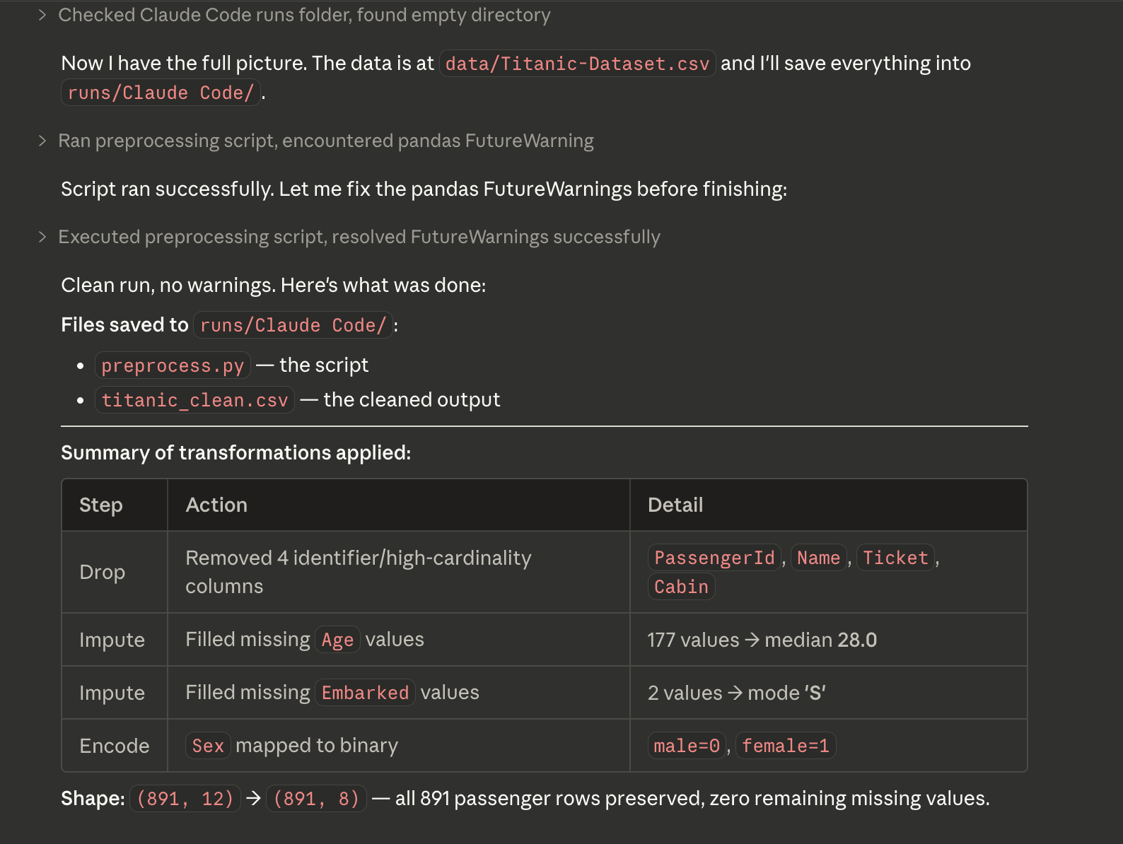
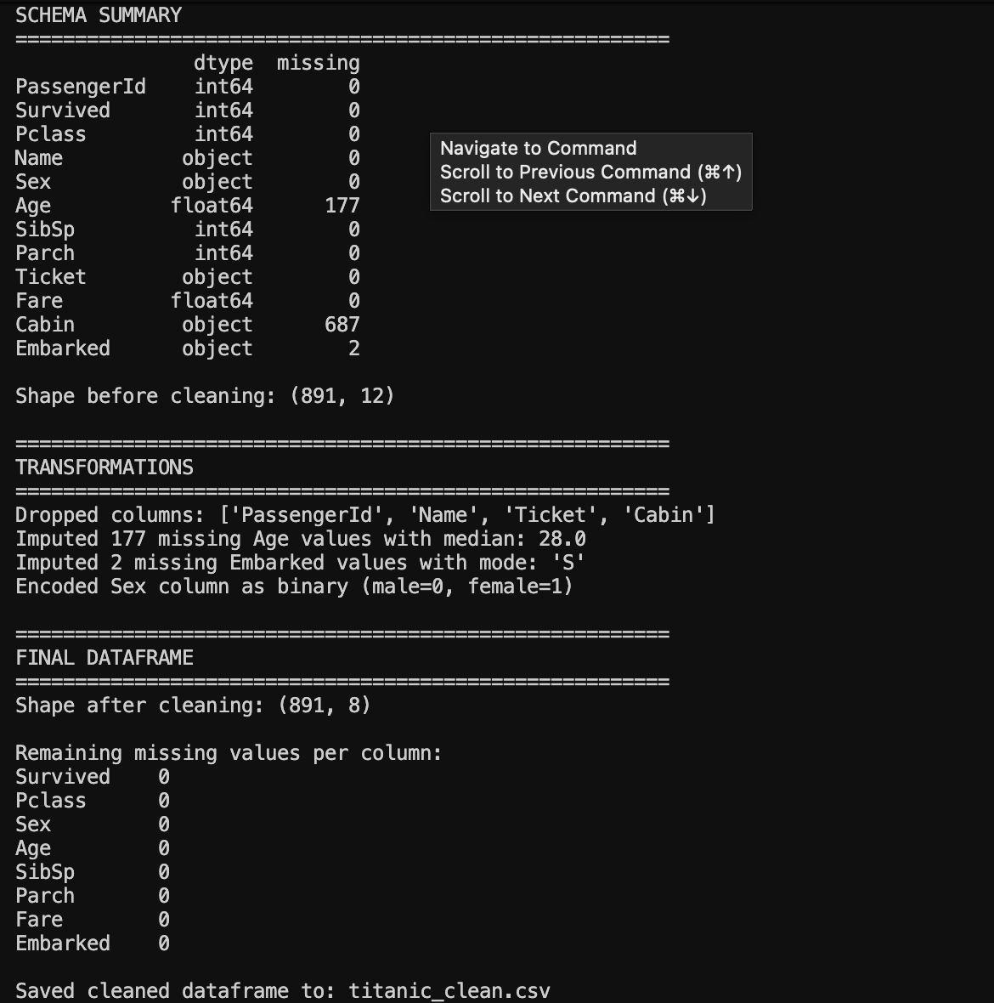

Task 2: Baseline Model:
Did it use a Pipeline (good practice) or fit transformers separately?
Yes it did.
Did any preprocessing happen before the split (leakage)?
No
Were the metrics reported on train or test? (check carefully)
Yes on test
Did it report all four metrics?
Yes
Were metrics in the plausible range (~0.78–0.82 accuracy)?
Yes right in the middle
All criteria success.

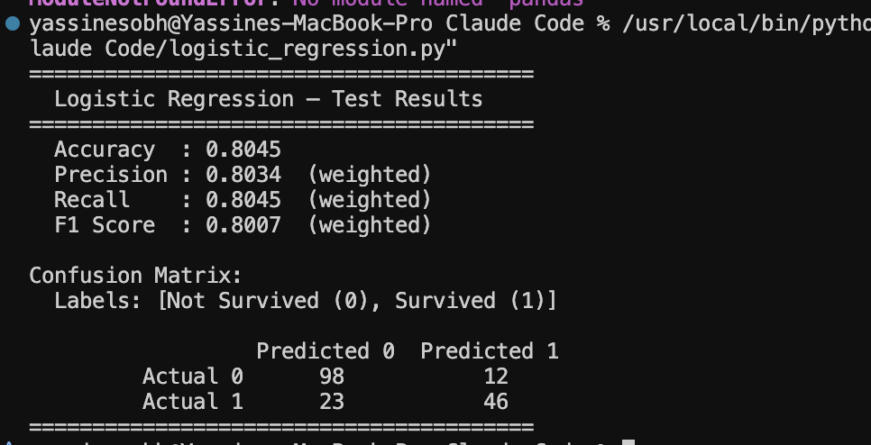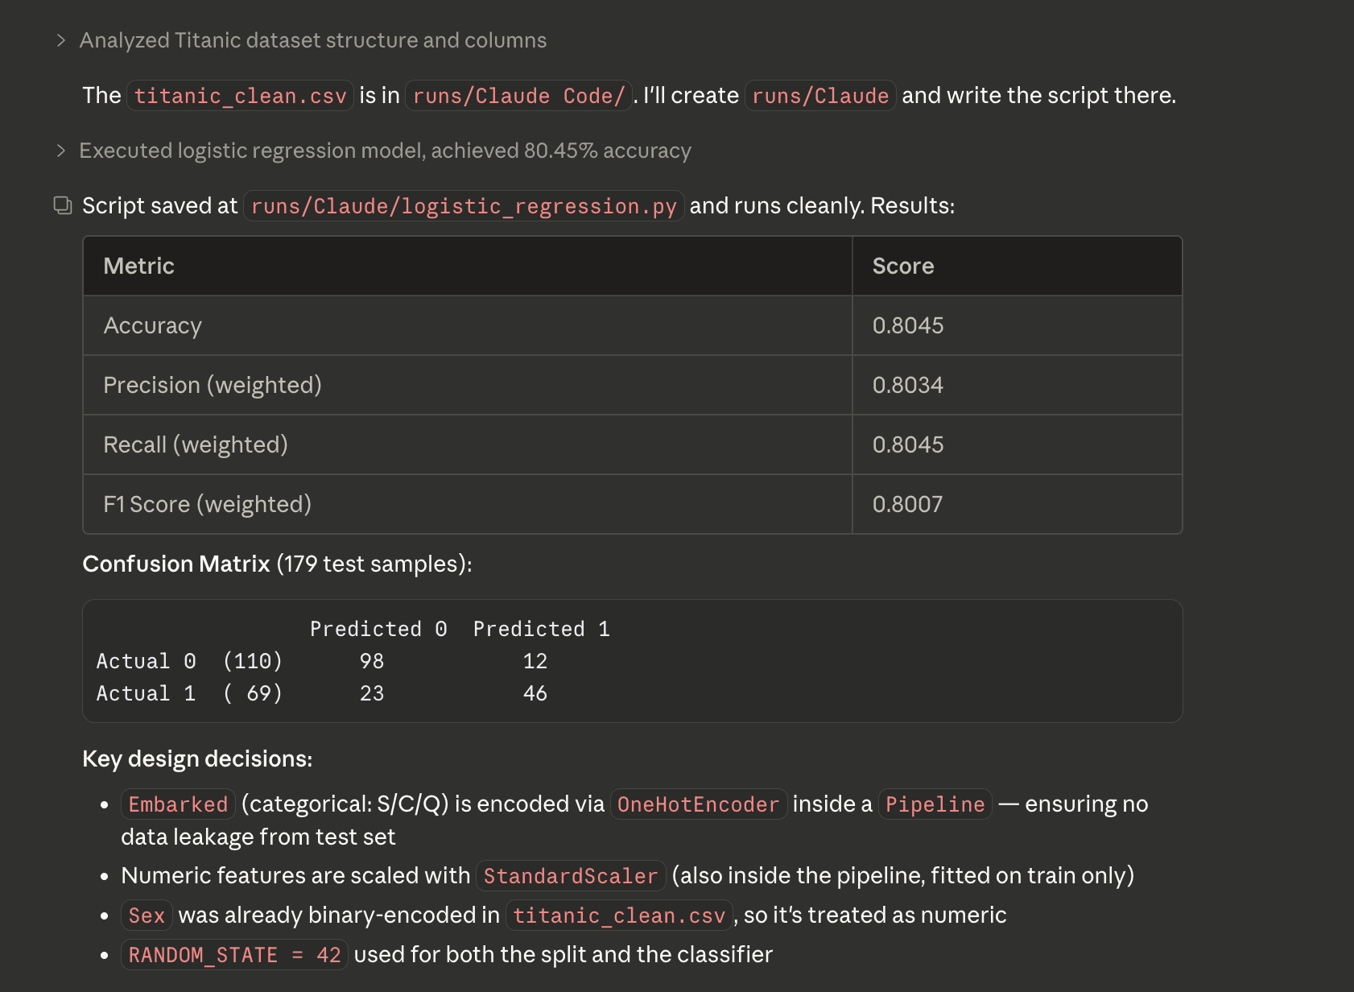

Task 3: Detecting Data Leakage
Did it spot the bug immediately or take multiple exchanges?
Yes.
Did it explain the mechanism of leakage, or just say “this is bad”?
Explained (Seen in the screenshot)
Did it correctly use scaler.fit(X_train) then
scaler.transform(X_test) — or use a Pipeline?
It did not use pipeline
Were the corrected metrics different from the original (they should be,
slightly)?
Unsure
Did it introduce any new bugs while fixing?
No
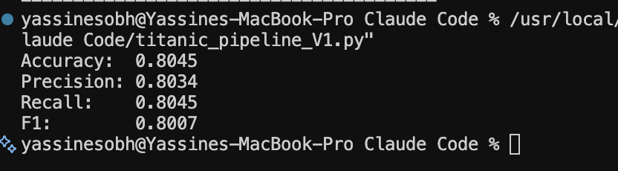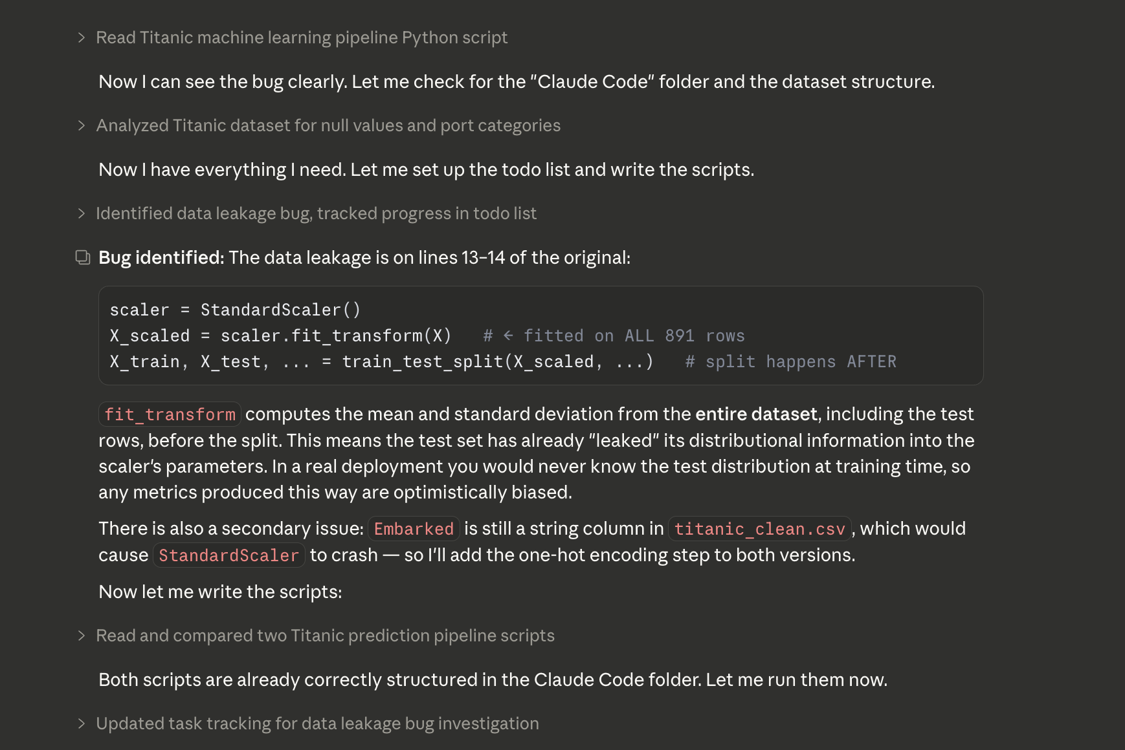

Task 4: Debugging
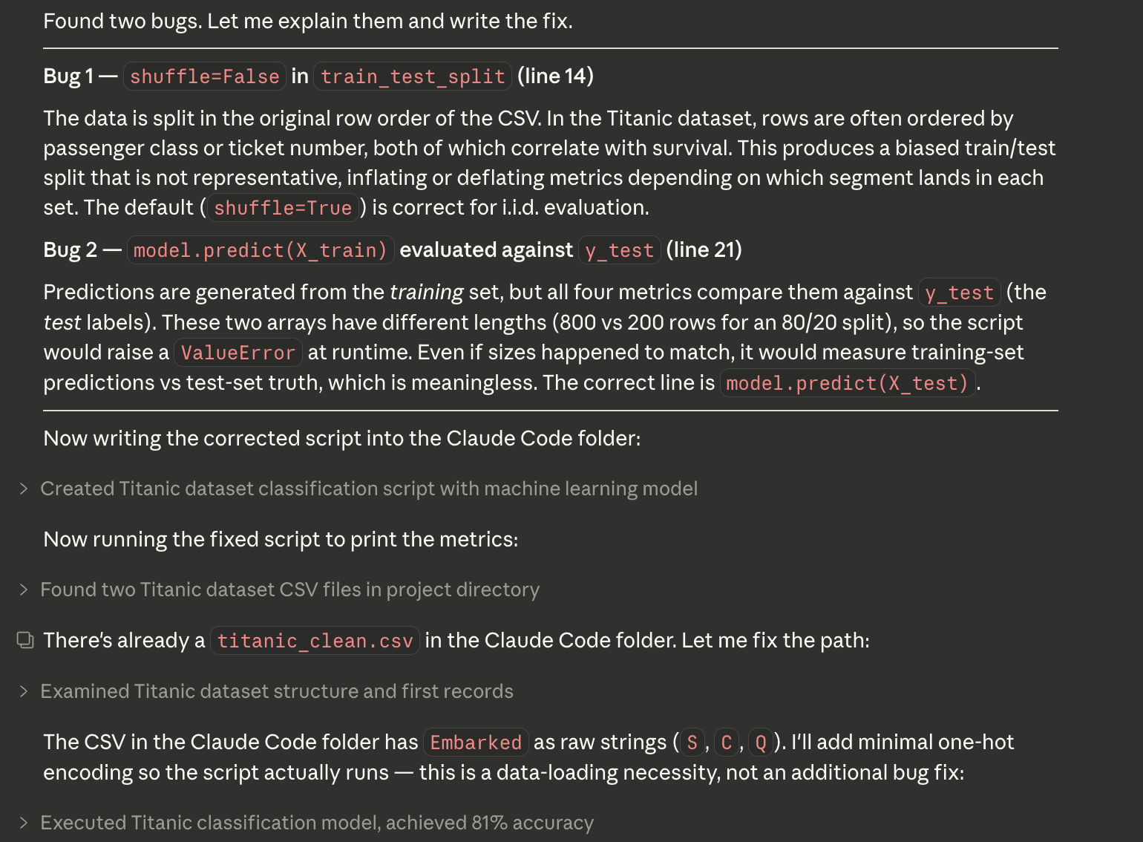
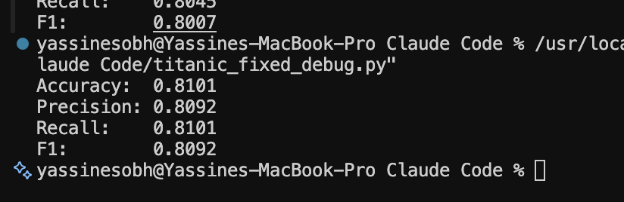

Did it find both bugs or just the obvious one (the shape error)?
Yes
Did it spot Bug 1 (shuffle=False) without being told there are two bugs?•
Yes
Did it explain the consequence of each bug, not just the fix?
Yes
Did the corrected script run without error?
Yes
Did it introduce any new bugs?
Yes

Task 5: EDA
- Did the script run end-to-end without error, or did it require correction?
  - It ran end to end
- Were all four PNG files actually saved to disk (verify by listing the directory), or did the tool only generate code without executing it?
  - Yes they were
- Were the survival rate figures correct (female ~74%, male ~19%; 1st class ~63%, 3rd class ~24%)?
  - Yes it was
- Did the tool hallucinate any column names not present in titanic_clean.csv (e.g. referencing the dropped columns PassengerId, Name, Ticket, Cabin)?
  - No it did not
- Did it use matplotlib.use('Agg') or equivalent to prevent display errors in a headless environment?
  - It did
- How many prompts did it take to reach a fully working solution?
  - 1

